Name: P. Sai Hallticket:2303A52395 Assginment:4.4 Task:01
- Sentiment Classification for Customer Reviews Scenario:
An e-commerce platform wants to analyze customer reviews and classify Week2
them into Positive, Negative, or Neutral sentiments using prompt engineering.
Tasks:
  - Prepare 6 short customer reviews mapped to sentiment labels.
  - Design a Zero-shot prompt to classify sentiment.
  - Design a One-shot prompt with one labeled example.
  - Design a Few-shot prompt with 3–5 labeled examples.
  - Compare the outputs and discuss accuracy differences.
Code:
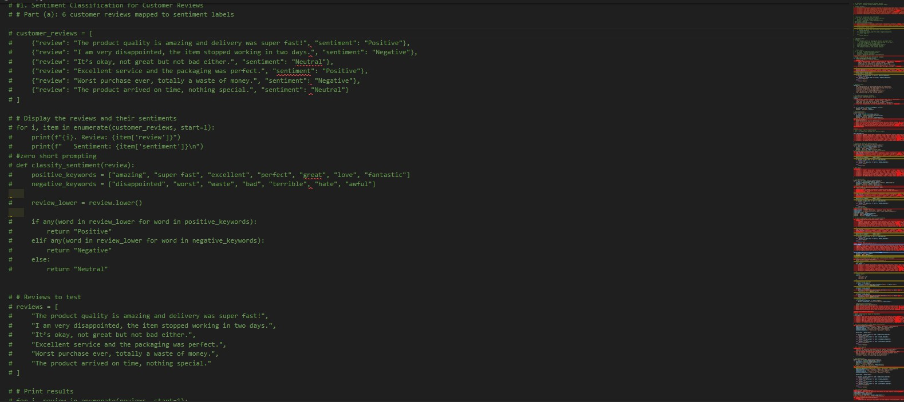
Output:

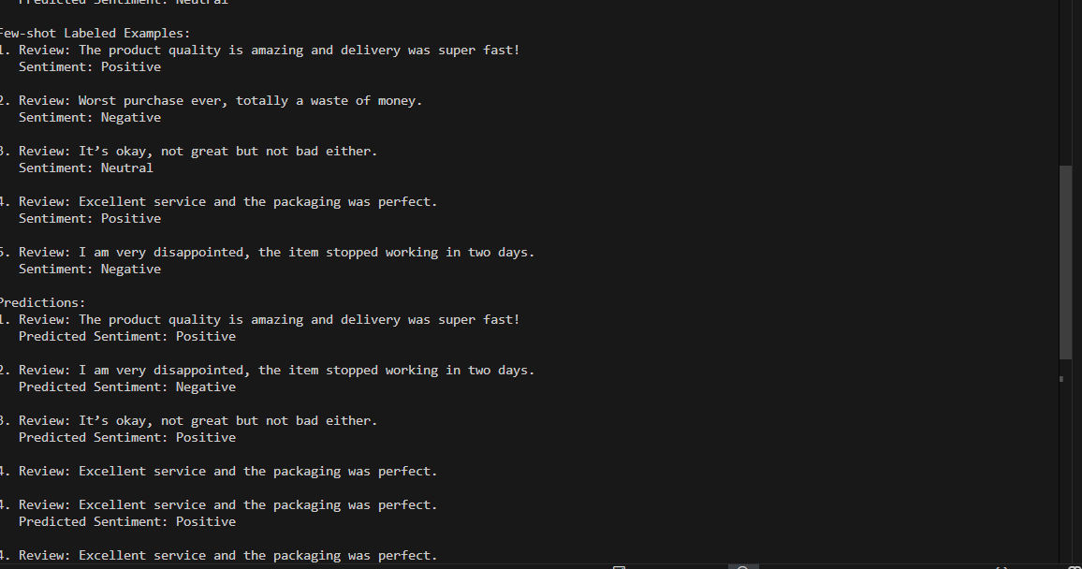
Observations:
give me observation in 5 line
    - Zero-shot prompting depends only on the instruction, so it may misclassify reviews when the sentiment is subtle or mixed.
    - One-shot prompting improves accuracy because the model gets one clear example to understand the labeling style.
    - Few-shot prompting gives the best performance since multiple examples help the model learn patterns more clearly.
    - Few-shot handles ambiguous or neutral reviews better compared to zero-shot and one-shot.
    - Overall, accuracy increases from Zero-shot → One-shot → Few-shot due to increasing contextual guidance.

Task 2: Email Priority Classification Code:

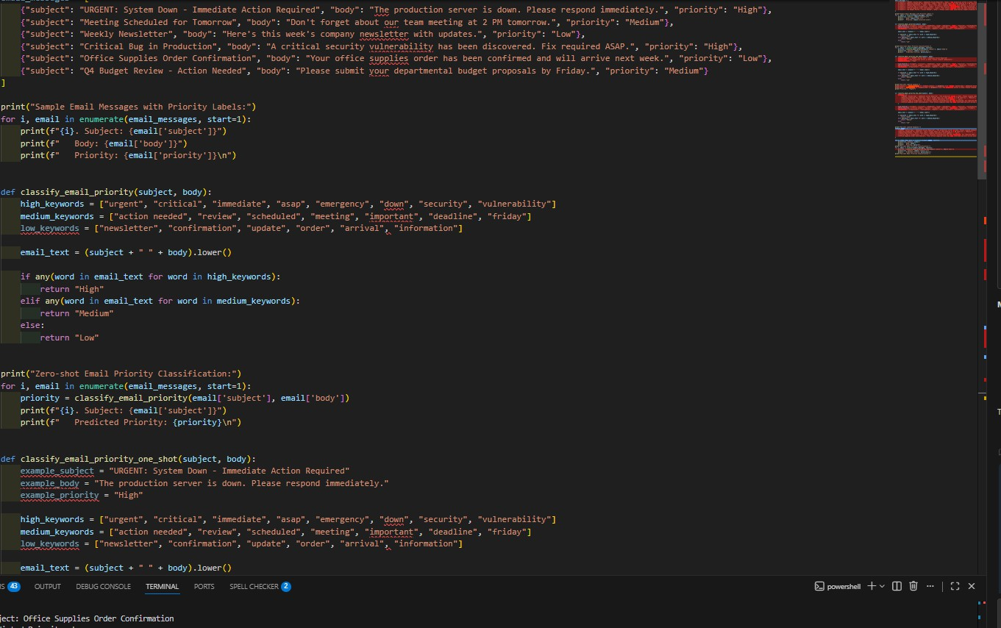

Output
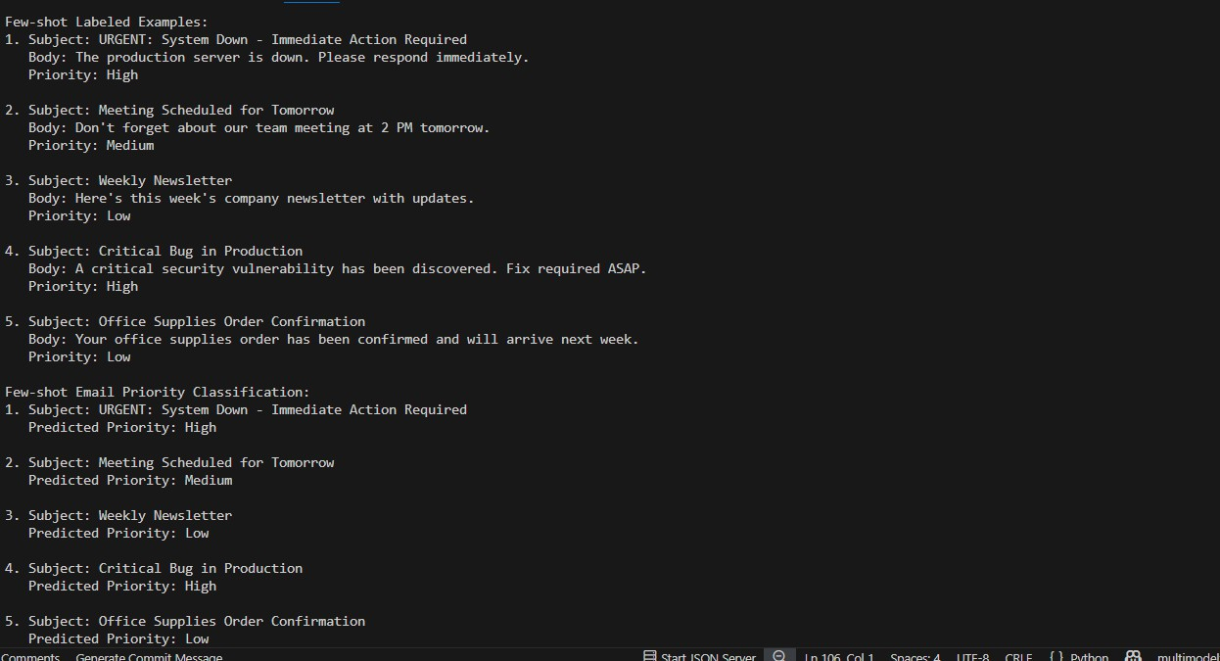
Observation:

- Zero-shot prompting works for obvious urgent or casual emails but can confuse Medium and Low priorities when wording is similar.
- One-shot prompting improves results because the model understands the priority format from one clear example.
- Few-shot prompting gives the most accurate classification since multiple examples define priority boundaries better.
- Few-shot handles borderline cases (like reminders vs. action-needed mails) more reliably.
- Overall reliability increases from Zero-shot → One-shot → Few-shot because more examples provide stronger context and guidance.

Task:3 Student Query Routing System Code
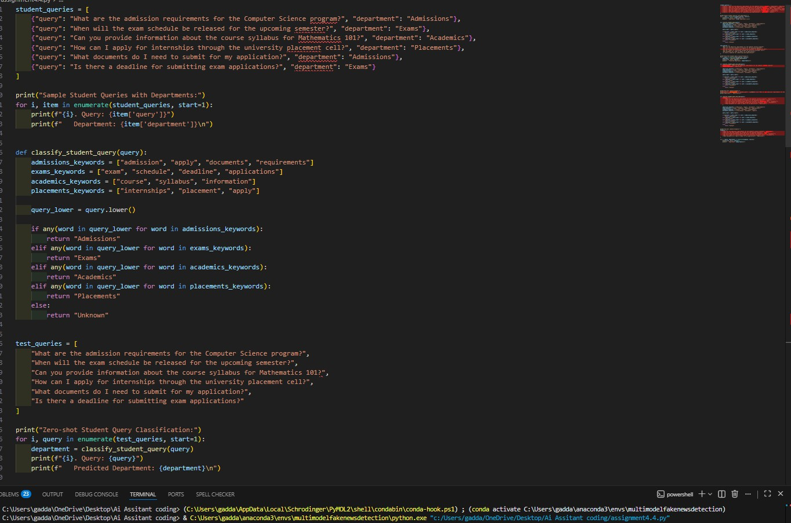

Output :
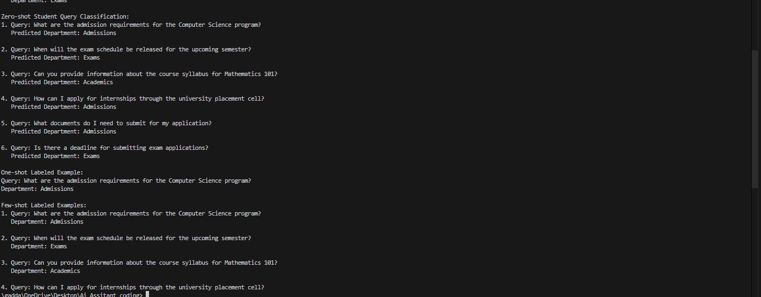
Observation:
- Zero-shot classification works for clear queries but may confuse departments when similar keywords appear (e.g., “apply” for Admissions and Placements).
- One-shot prompting improves accuracy by giving the model a reference example to understand routing style.
- Few-shot prompting provides the best results because multiple
examples clearly define each department’s intent.
- Contextual examples help reduce ambiguity and make boundaries between departments more distinct.
- Accuracy improves from Zero-shot → One-shot → Few-shot due to stronger guidance and better pattern learning

Task4: Chatbot Question Type Detection Code:

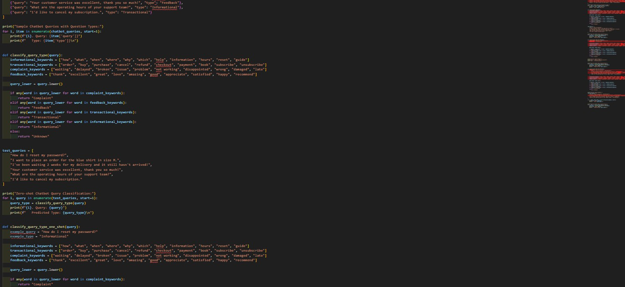
Output:
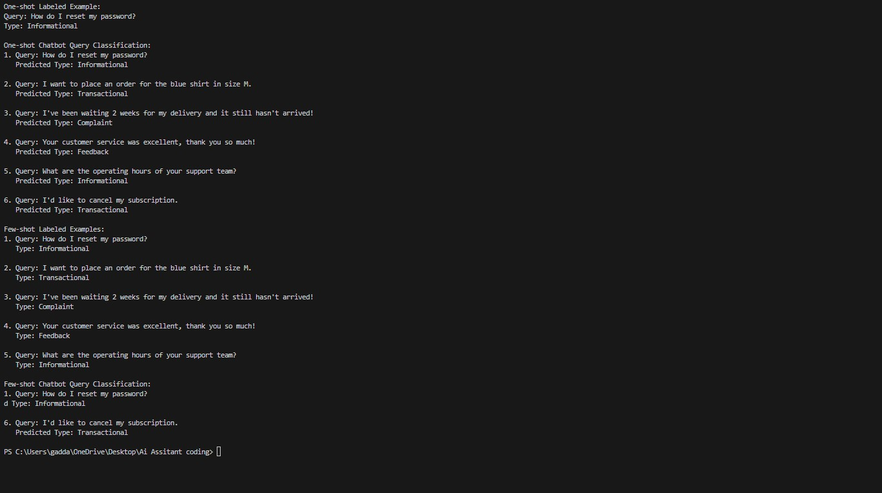
Observation:
- Zero-shot prompting works for simple queries but often struggles with ambiguous ones that contain multiple intents (e.g., complaint + transaction).
- One-shot prompting improves correctness by showing one clear example of how classification should be done.
- Few-shot prompting gives the best accuracy because multiple examples define each category more clearly.

- Few-shot handles ambiguity better by learning which intent should take priority when overlaps occur.
- Overall, Few-shot > One-shot > Zero-shot in both correctness and reliability for chatbot question type detection.

Task5:emotion Detection in Text Code:
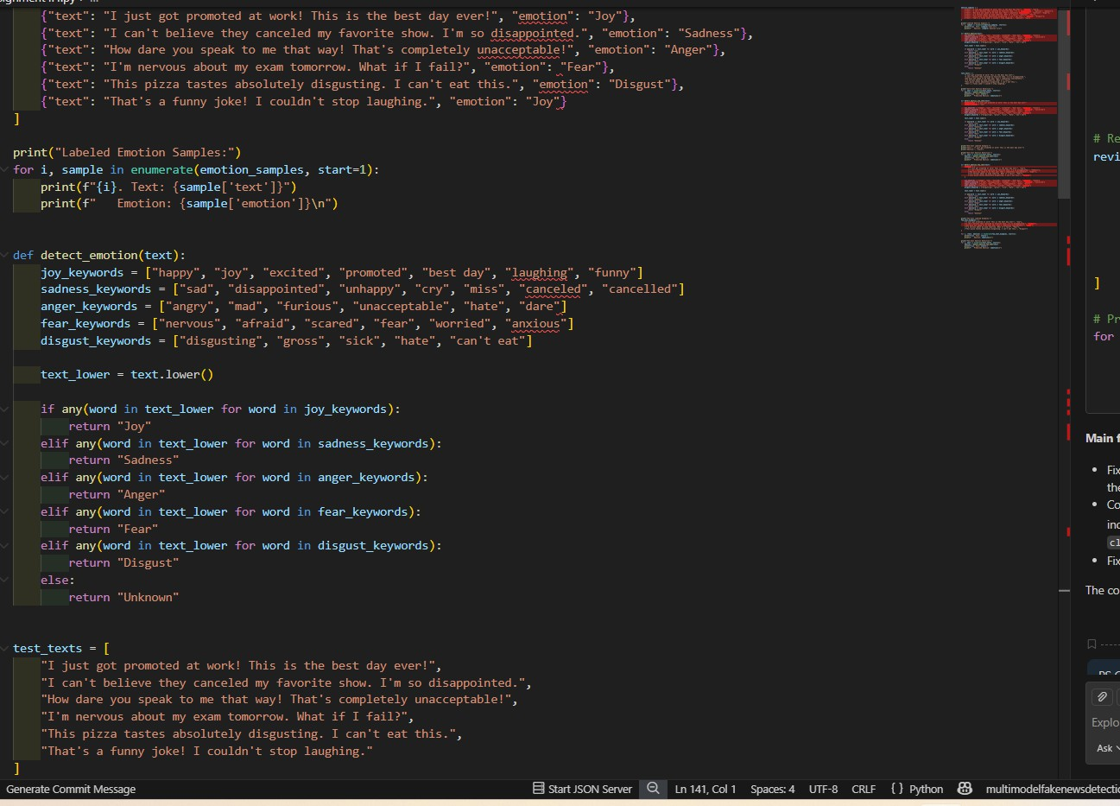

Output:
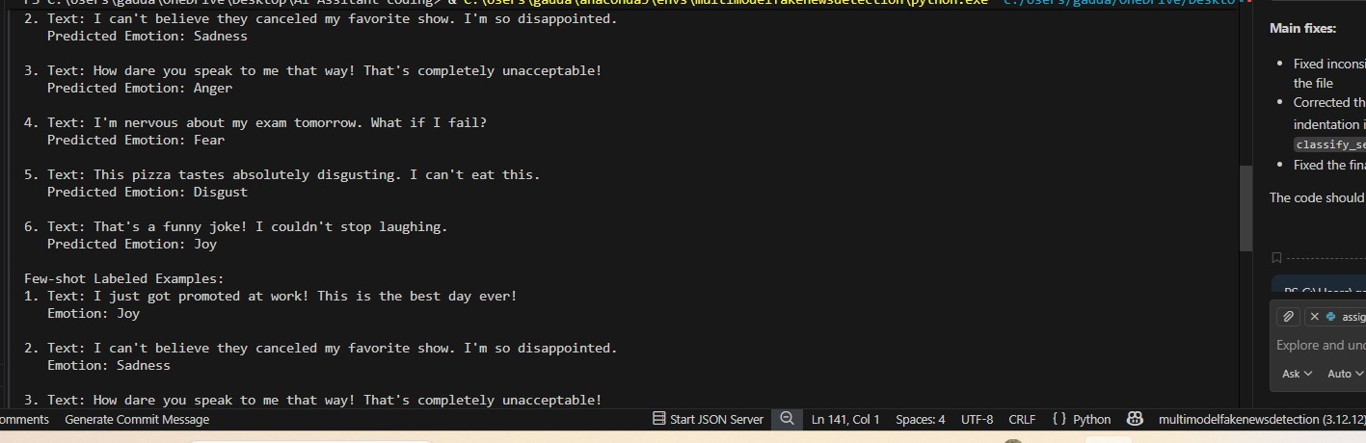
Observation:
Zero-shot prompting can detect clear emotions but often struggles with mixed or subtle emotional expressions.
One-shot prompting improves emotion recognition by giving a reference example of how emotions should be labeled.
Few-shot prompting gives the highest accuracy because multiple labeled emotions help the model understand emotional patterns better.
Few-shot handles ambiguous emotions (like Sad + Anxious) more effectively by learning distinctions from examples.
Overall, ambiguity handling and reliability increase from Zero-shot → One- shot → Few-shot.

